Ques1: Write a program for the following

• Read all elements from ArrayList by using Iterator.

• Create duplicate object of an ArrayList instance.

• Reverse ArrayList content.

Source Code

**package** Lab11;

**import** java.util.ArrayList;

**import** java.util.Iterator;

**import** java.util.*;

**public** **class** ArrayList1 {

**public** **static** **void** main(String args[]){

System.***out***.println("Hitendra Sisodia");

System.***out***.println("500091910");

ArrayList<String> list=**new** ArrayList<String>();

list.add("A");

list.add("B");

list.add("C");

list.add("D");

// Traversing list through Iterator

Iterator itr = list.iterator();

**while**(itr.hasNext()){

System.***out***.print(itr.next()+" ");

}

System.***out***.println();

// List clone

ArrayList<String> arrayListClone = (ArrayList<String>) list.clone();

System.***out***.println("Clone List: "+arrayListClone);

Collections.*reverse*(arrayListClone);

ArrayList<String> array = **new** ArrayList<String>();

// Reverese List

**for**(**int** i = list.size() - 1 ; i >= 0 ; i--) {

array.add(list.get(i));

}

System.***out***.println(array);

// Traversing Reverse list through Iterator

System.***out***.print("Elements after reversing: ");

Iterator itr1 = arrayListClone.iterator();

**while**(itr1.hasNext()){

System.***out***.print(itr1.next()+" ");

}

}

}

Output

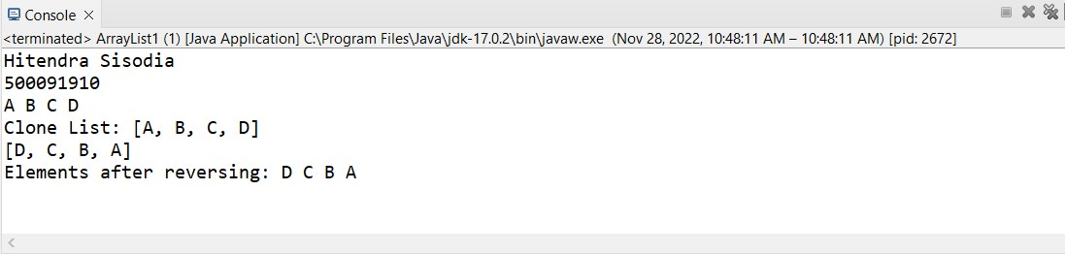

Ques2: Write a program for the following HashMap

• find whether specified key exists or not.

• find whether specified value exists or not

• get all keys from the given HashMap

• get all key-value pair as Entry objects

Source Code

**package** Lab11;

**import** java.util.*;

**import** java.util.Map.Entry;

**public** **class** HashMap1 {

**public** **static** **void** main(String[] args) {

System.***out***.println("Hitendra Sisodia");

System.***out***.println("500091910");

HashMap<Integer, String> hash_map = **new** HashMap<Integer, String>();

// Mapping string values to int keys

hash_map.put(10, "A");

hash_map.put(15, "B");

hash_map.put(20, "C");

hash_map.put(25, "D");

hash_map.put(30, "E");

// Displaying the HashMap

System.***out***.println("Mappings are: " + hash_map);

// Checking for the key_element '20'

System.***out***.println("Is the key '20' present: " + hash_map.containsKey(20));

// Checking for the value present or not

System.***out***.println("Is the value 'F' present: " + hash_map.containsValue("F"));

// get keys from given hashmap

System.***out***.print("keys are: ");

**for**(Integer key: hash_map.keySet()){

System.***out***.print(key+" ");

}

System.***out***.println();

// get all keyvalue pair as entry object

**for**(Entry<Integer, String> temp: hash_map.entrySet()) {

System.***out***.println(temp.getKey() + " "+ temp.getValue());

}

}

}

Output

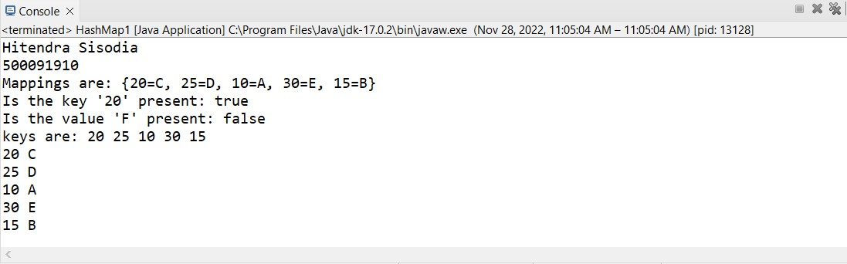

Ques3: Write a program for the following HashSet

• copy another collection object to HashSet object.

• delete all entries at one call from HashSet

• search user defined objects from HashSet

Source Code

**package** Lab11;

**import** java.util.*;

**public** **class** HashSet1 {

**public** **static** **void** main(String args[]) {

System.***out***.println("Hitendra Sisodia");

System.***out***.println("500091910");

ArrayList<String> list=**new** ArrayList<String>();

list.add("A");

list.add("B");

list.add("C");

list.add("A");

HashSet<String> set = **new** HashSet(list);

System.***out***.println("An initial Set of elements: "+set);

**if**(set.contains("g")) {

System.***out***.println("Yes Set contains 'F' String");

}

**else** {

System.***out***.println("No Set do not contains 'F' String");

}

set.clear();

System.***out***.println("After clear(): "+set);

}

}

Output

